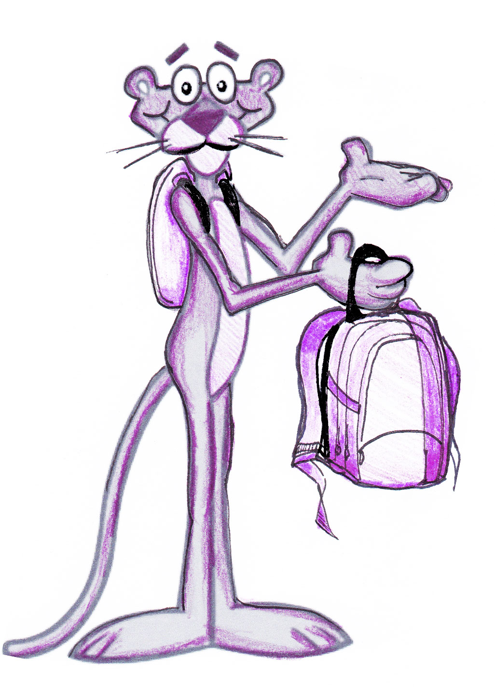
PARENTS!!!!
Are you interested in helping us figure out how to lighten the load of these backpacks?
Join our Backpack Committee. First Meeting is (INSERT DATE/TIME/LOCATION).

NAME EMAIL

